Course Logistics

We hope that you are excited about your course with Claire at the Equine Savvy Centre.
Claire has spent lots of time over the years developing the yard to best accommodate student’s horses and allow access to the sand menage and horsemanship playground. Every year, Claire, Rosie and other invited instructors teach courses from this venue and Claire strives to improve the facilities year on year for the best experience for students and their horses. We hope you enjoy your time there.
We pride ourselves on being a welcoming and friendly yard for everyone, to create a positive environment to relax and learn in. If you need anything during your stay please ask Rosie or Claire.
Below are some logistics for you to set you up as best we can.

Course Details:
All full day courses (unless specified) will start at 9.30 am and generally run to approx. 4pm but may on occasions run over
Short day courses (immersion week and fun camps) are 9.30am -2.30pm and will have short break late morning (15 mins). From 2.30pm the day is yours to relax with your horse or use the facilities.
Focus Mornings start at 9.30 for set up. Then sessions start at 10am till 1 pm.
Lunches are NOT included on any course. We recommend that you bring your own. However, there is a shop at the top of the road open daily if you need anything.
We will provide tea and coffee throughout the day.

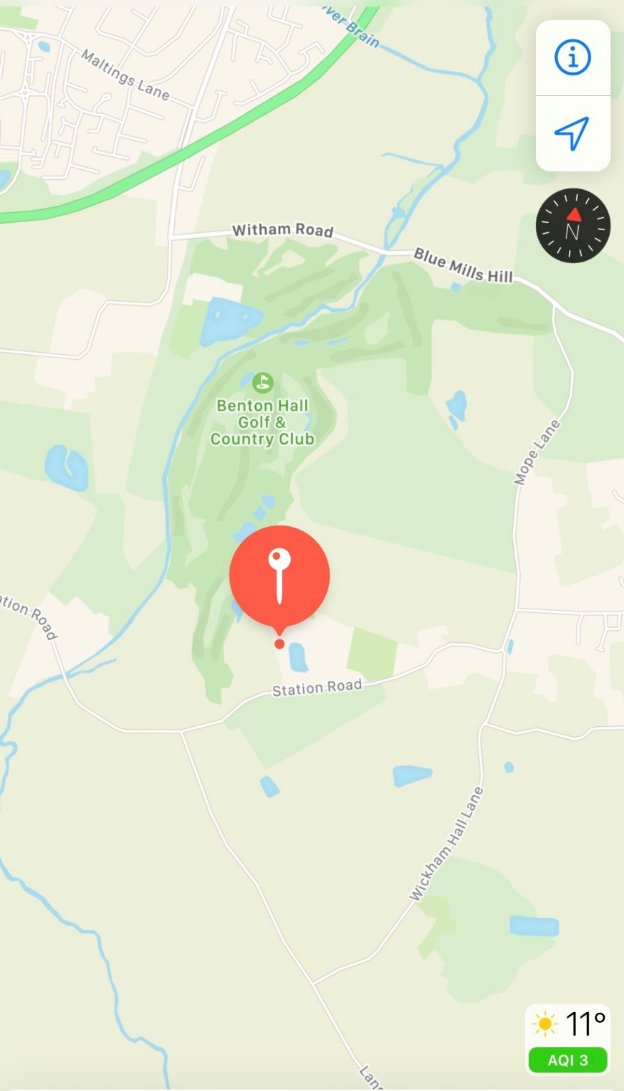
Venue Address:
Equine Savvy Centre,
Station Road,
Wickham bishops,
CM8 3JL
Please keep right halfway down the long gravel drive this will bring you to the Equine Savvy Centre
** some sat navs try to take you through Benton Hall golf club. This is wrong. If this happens;
- Come out of the golf club and turn left.
2. Turn left at the T junction onto Maldon rd
- Take the next road on the Left station rd
- After 2 small bridges take the first road on the left. This is the 2nd part of Station rd
- We are the first long gravel driveway on the left

Course check in:
Please let Claire know in advance which option best suits you or if anything changes with your arrangements.
- You are welcome to check in the morning of the course. Please leave plenty of time to be unloaded and parked up by 9am. Please notify us of your likely arrival time so we can ensure someone is there to greet you and unlock gates.
- If you would prefer to arrive the day prior to your course start day. Please aim to arrive between 1-2pm. If you are unable to check in between these times, please let us know asap.

Student accommodation
At this time, we are not able to offer overnight camping in tents or horseboxes but will hope this maybe an option in the future.
We highly recommend.
The Lion inn in Boreham 01245394900
If this is outside your budget there are alternates on Airbnb. More details coming soon

ESC Facilities;
Gates will be unlocked at the latest on course days at 8.30am and will be closed at 5pm
If it is dry conditions, we are happy for you to park on the grass to keep the track free of others to pass. If it has recently rained and the ground is soft, please try to stay on the hard standing.

All trailers, horseboxes and cars on courses are required to park on the grass above the menage. We put a lot of effort into our security but any vehicle left is at your own risk.
We have a sand menage and two large fields that you are welcome to use whilst with us. However, we do ask that you close gates and clean up after use. Thank you

Horse Accommodation:
For overnight courses horses will be allocated either a stable or an electric fenced pen. If you have a preference or your horse will push on electric fencing, please let Claire know asap.
The following is included for your course dates only;
- Hay
- Bedding (stables)
- Overnight stabling cost

If you wish to attend a day or two earlier this will be charged at £10 per night/ per horse
You will need to bring the following for your horse;
- Mucking out/ poo picking tools
- Water buckets
- Hard feed etc
- Haynets

Equipment needed:
Please clearly mark all of your equipment.

- 12ft and 22ft lines
      - stick and string
      - hackamore and snaffle bridle,
      - riding hat and appropriate boots
      - saddle.
      - Fly spray
      - Suntan lotion
      - Lunch
      - Water bucket
      - Waterproofs
We will be out whatever the weather! So please be prepared for all elements - sun cream - rain coats!
During the summer months the playground can be firm under foot, if your horse is particularly sensitive and you feel your horse needs boots, please use them.
If you have any questions please just ask.
We hope that you all have an amazing time!
Yours Naturally
Claire & Rosie
Equine Savvy Instructors

